**1. Define the target audience and geography of the application.**

* Target audience:

Analytics data from [pro.similarweb.com](https://pro.similarweb.com/#/digitalsuite/websiteanalysis/audience-demographics/*/999/3m?webSource=Total&key=mymarket.ge):

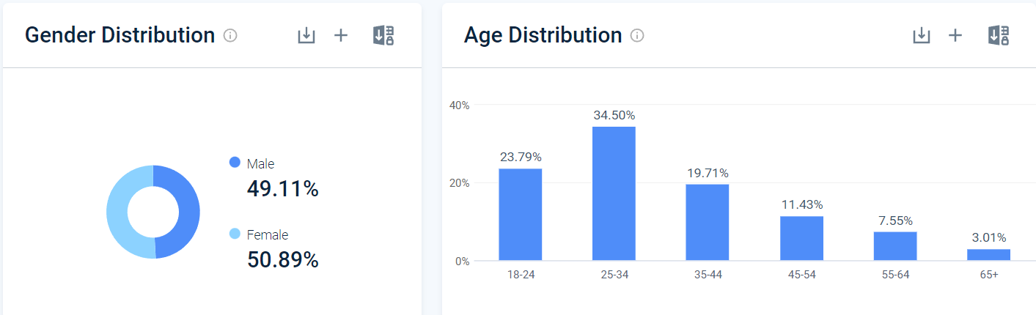

The main age of users is from 18 to 44 years old.

The ratio of male and female users is almost equal

* Geography: Georgia
  + According to Delivery conditions online purchased products can be delivered both in Tbilisi and in the regions.

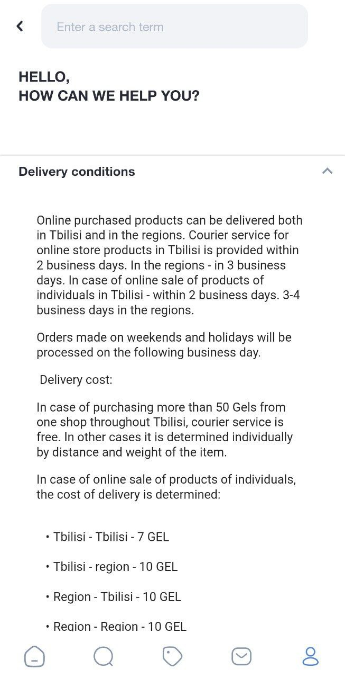

* + Analytics data from [pro.similarweb.com](https://pro.similarweb.com/#/digitalsuite/websiteanalysis/overview/website-performance/*/999/3m?webSource=Total&key=mymarket.ge):

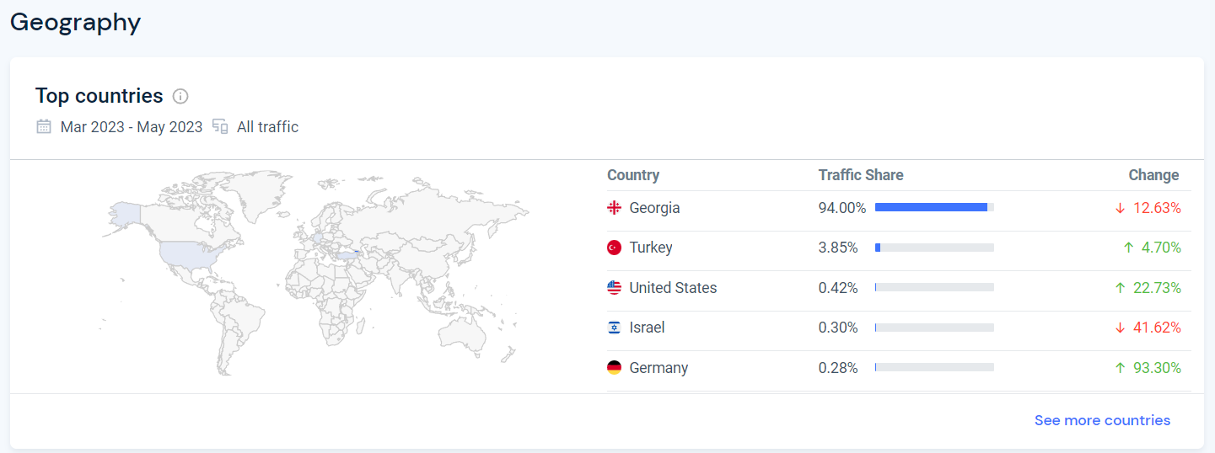

**2. Define application requirements (versioning, supported devices, etc.).**

**Android devices**

**Application version:**

versionCode="38"   
versionName="1.0.38"

**Android version:**

minSdkVersion="21" - Minimal supported android version (Android 5.0 [Lollipop](https://developer.android.com/about/versions/lollipop))

targetSdkVersion="30" – Target android version (Android 11 [Red Velvet Cake](https://developer.android.com/about/versions/11))

**Application permissions:**

uses-permission

android:name="android.permission.INTERNET" - Allows applications to open network sockets

uses-permission

android:name="android.permission.ACCESS_NETWORK_STATE" – Allows

applications to access information about networks.

uses-permission

android:name="android.permission.WAKE_LOCK" - Allows using PowerManager

WakeLocks to keep processor from sleeping or screen from dimming.

uses-permission

android:name="android.permission.VIBRATE" - Allows access to the vibrator.

uses-permission

android:name="android.permission.READ_EXTERNAL_STORAGE" - Allows an

application to read from external storage.

uses-permission

android:name="android.permission.WRITE_EXTERNAL_STORAGE"-Allows an application to write to external storage.

uses-permission

android:name="android.permission.CAMERA" - Required to be able to access the

camera device.

uses-permission

android:name="android.permission.RECORD_AUDIO" - Allows an application to

record audio.

uses-permission

android:name="com.google.android.finsky.permission.BIND_GET_INSTALL_REFERRER_SERVICE"

**Other features:**

supportsRtl="true" - Declares whether your application is willing to support right-to-left (RTL) layouts.

usesCleartextTraffic="true" - Indicates whether the app intends to use cleartext network traffic, such as cleartext HTTP.

Orientation – Portrait

Supports Dark mode

Screen resolution - no limits

**Supported languages:**

GEO (Georgian language)

ENG (English language)

RU (Russian language)

**Supported devices:**Requires Android 5.0 and up

**Apple devices**

**Compatibility**

iPhone

Requires iOS 10.0 or later.

iPad

Requires iPadOS 10.0 or later.

iPod touch

Requires iOS 10.0 or later.

Mac

Requires macOS 11.0 or later and a Mac with Apple M1 chip or later.

**3. Device matrix**Analytics data from [Statcounter](https://gs.statcounter.com/vendor-market-share/mobile/russian-federation):

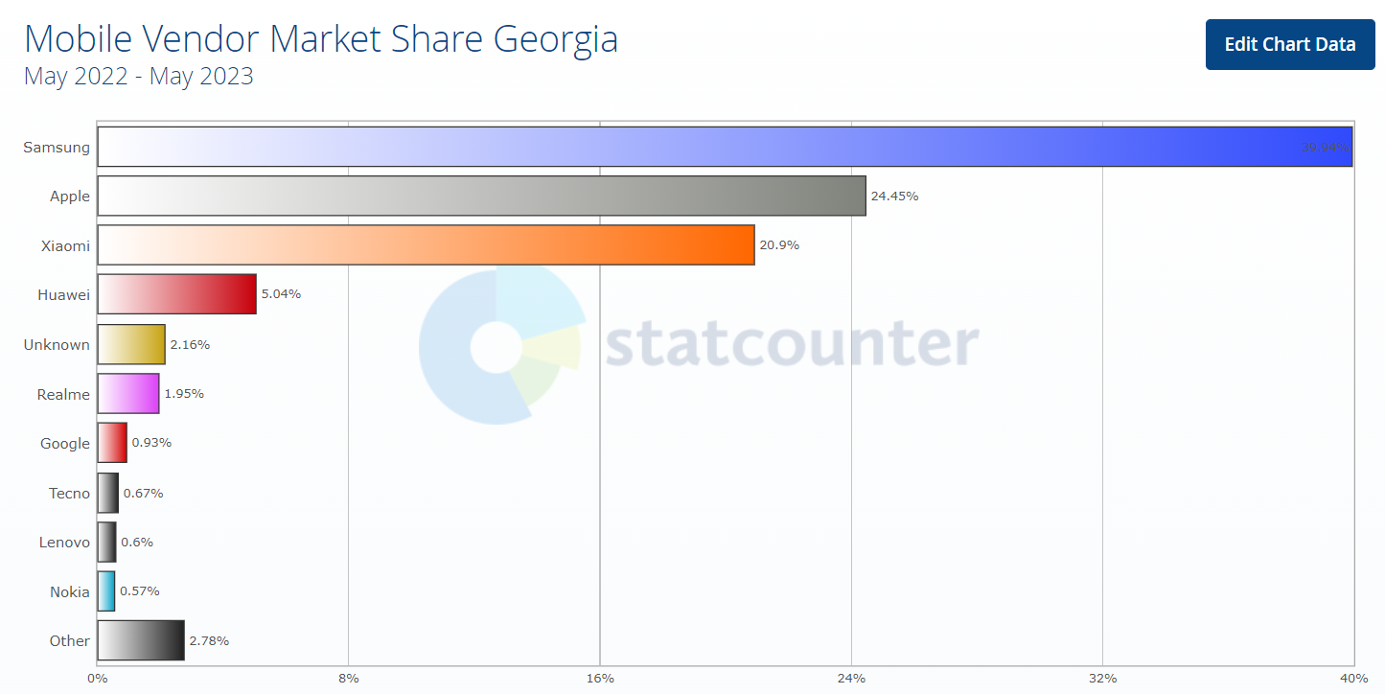

As we can see, the most popular mobile vendors in Georgia are Samsung, Apple, Xiaomi, Huawei.

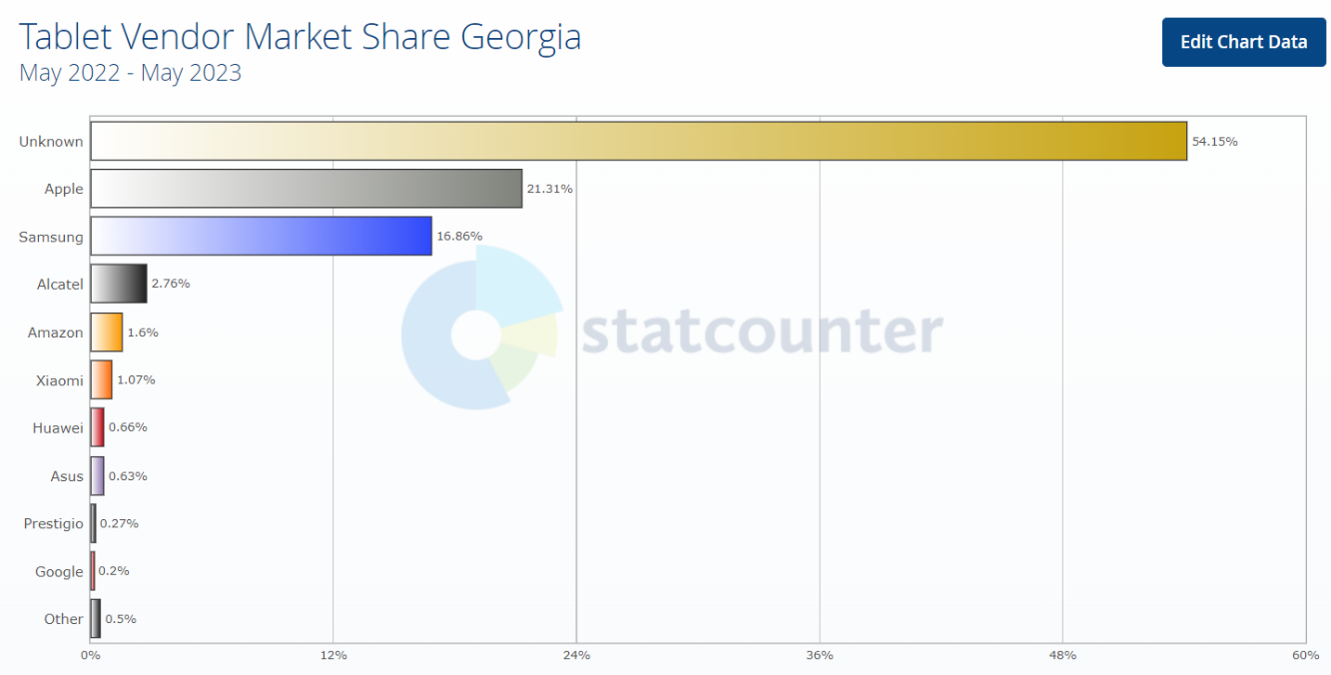

As we can see, the most popular mobile vendors in Georgia are Apple, Samsung and from unknown manufacturers.  
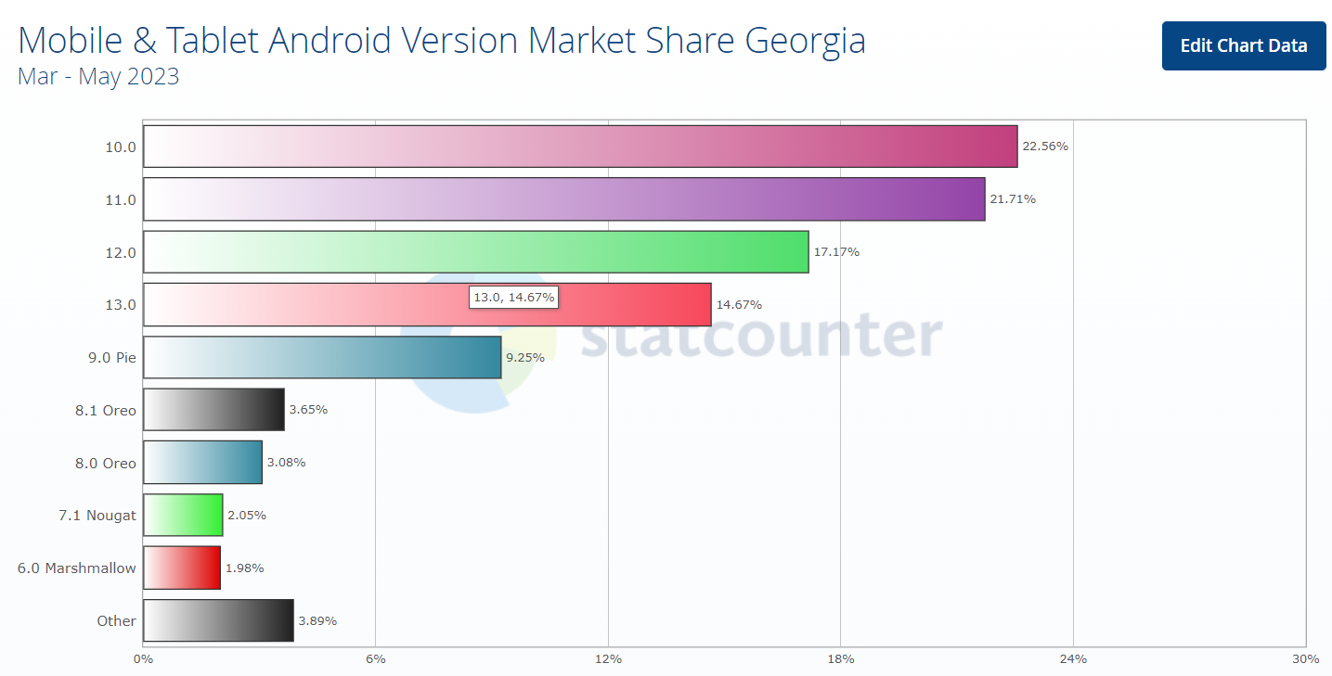

Most popular Android versions are 10.0, 11.0 and 12.0.

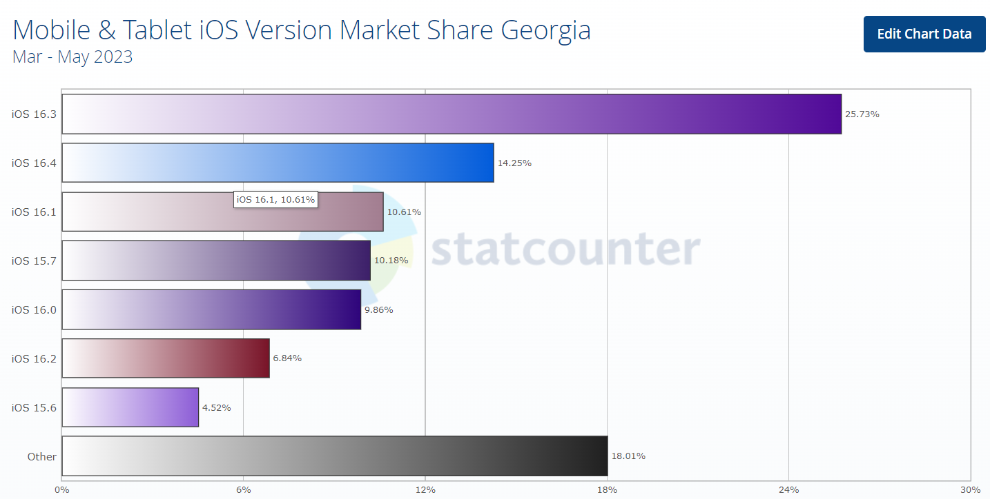

Most popular iOS versions are iOS 16.3, iOS 16.4 and iOS 16.1.

**Device Matrix for Android devices**

|  |  |  |  |  |  |  |  |  |
| --- | --- | --- | --- | --- | --- | --- | --- | --- |
| **Manufacturer** | **Model** | **Ratio of sides** | **Display** | **Resolution** | **Release** | **OS** | **Features** | **Price** |
| Samsung | Galaxy Z Fold 4 | 23.1:9/6:5 | 6.2"/7.6" | 1812 x 2176 pixels | 2022 | Android 12  One UI 4.1.1 | Folding | 1884$ |
| Samsung | S23+ | 19.5:9 | 6.6" | 1080 x 2340 pixels | 2023 | Android 13 One UI 5.1 |  | 999.99$ |
| Xiaomi | 13 Pro | 20:9 | 6.73" | 1440 x 3200 pixels | 2023 | Android 13 MIUI 14 |  | 1381$ |
| Samsung | Galaxy Tab S6 Lite | 5:3 | 10.4" | 2000x1200 pixels | 2022 | Android 12 One UI 4.1 |  | 429.99$ |
| Google | Pixel 7 Pro | 19.5:9 | 6.7" | 1440x3120 pixels | 2022 | Android 13 |  | 699$ |
| BLU | M8L | 16:10 | 8.0" | 800 x 1280 pixels | 2020 | Android 11  Go edition |  | 72$ |
| Huawei | Y8p AQM-LX1 | 20:9 | 6.3" | 1080x2400 pixels | 2020 | Android 10.0 |  | 250$ |

**Device Matrix for Apple devices**

|  |  |  |  |  |  |  |  |  |
| --- | --- | --- | --- | --- | --- | --- | --- | --- |
| **Manufacturer** | **Model** | **Ratio of sides** | **Display** | **Resolution** | **Release** | **OS** | **Features** | **Price** |
| Apple | iPhone 5s | 16:9 | 4" | 640 x 1136 pixels | 2013 | Apple iOS iOS 12 | Home button | 71.92$ |
| Apple | iPhone 14 Pro Max | 19.5:9 | 6.7" | 1290x2796 pixels | 2022 | Apple iOS iOS 16 | Dynamic island | 1099$ |
| Apple | iPad Air | 4:3 | 10.9" | 2360x1640 pixels | 2013 | Apple iOS  iOS 12 | Home button | 299$ |
| Apple | iPad Pro (12.9-inch) (6th generation) | 4:3 | 12.9" | 2732 x 2048  pixels | 2022 | Apple iOS iOS 16 |  | 2567.80$ |
| Apple | iPod touch  (7th generation) | 16:9 | 4" | 1136 x 640  pixels | 2019 | iOS 12 | Home button | 204$ |
| Apple | Macbook Air 13" |  | 13.3" | 2560 x 1600  pixels | 2020 | macOS macOS Ventura |  | 1299$ |